Serious Driving Game

Table of Contents

1. Pitch 3

1.1. Group Members 3

1.2. Game Title 3

1.3. Concept 3

1.4. Learning Outcomes 3

1.5. Setting 3

1.6. Genre 3

1.7. Target Platform 3

1.8. Target Audience 4

2. Game Design 5

2.1. Story 5

2.2. Missions/Scenarios 5

2.3. Goals 5

2.4. Scenarios 5

2.4.1. Roundabout 5

2.4.2. Motorway slip road merging 5

2.4.3. Crossroads 6

2.4.4. T- Junction 6

2.4.5. Scenarios Breakdown 6

Example Breakdown 6

Scoring 6

3. Difficulty 7

4. Technical Design Specification 7

Development Breakdown 7

Game Engine 7

Modeling Software 7

Minimum Requirements 7

Development Methodology 7

Testing Methodology 7

Implementation 7

Car Driving 7

City 8

Scenarios 8

AI 8

Basics 8

Path Following 8

Collision Avoidance 8

Traffic Rule Following 8

Gameplay Mechanics 9

Controls 9

Objectives 10

Actions 10

Menus 10

# Pitch

## Group Members

Darren Griffiths

Kamil Witonski

## Game Title

Serious Games – A Serious Driving Game

## Concept

The idea of the game is to educate future drivers. Reducing fear, anxiety and low confidence when thinking about driving. Increasing clarity of rules on the road within a risk-free virtual environment that could potentially lead to lowering risks and accidents. Users are encouraged to take advantage of this software prior to taking driving lessons with a real instructor. With this serious driving game users will have a better understanding of the highway code and will have the opportunity to undertake some situations. Situations that the developers have thought about that may not be included in your driving lessons/test. Situations that they think would help younger leaners will benefit encountering within their game. Doing this idea virtually in a 3D world allows us to show general road situations in a brand-new angle for the students and for existing drivers that may still find this game educational.

## Learning Outcomes

The game is intending to educate the player on various driving scenarios and how to proceed during them, our proposed learning outcomes are:

* Ability to safety navigate a roundabout
* Ability to safety navigate a crossroad
* Ability to safety merge onto a motorway

## Setting

The game will be set in a small town of a fictional location. Filled out with day to day scenarios. Such as, parking lots, parking bays, round-a-bouts, traffic lights and various crossings. With surroundings filled with road signs and even some common scenery that a small town may entail.

## Genre

Serious Driving is a 3D Educational Game.

## Target Platform

The game is intended to be released on Windows PC and Mac.

## Target Audience

The game is intended for mature audience located in Great Britain who are ready to take on the driving lessons in the real world, this is 17 years old and above in the UK. We also encourage a slightly younger audience to dip their feet into this risk-free driving simulator.

# Game Design

## Story

The game doesn’t feature a story that the player can follow, it is intended as an educational game and there is no place for a story at this time for this type of a game. The game will feature a series of missions/scenarios that the player can undertake that will explain and demonstrate various rules of the road and how to behave during those scenarios.

## Missions/Scenarios

The game is split up into various scenarios that consist of some of the day today driving situations new drivers will be facing. The are individual isolated scenarios that can be played through by the player, each with a series of hints and tips on how to successfully complete those

## Goals

The main goal is to increase the knowledge on driving for the players, also to prepare them for some of the situations they might face during their driving career. This is specifically for people who haven’t driven before or have done very little of real world driving.

The game will be considered successful when the player that use the game increase their knowledge

## Scenarios

### Roundabout

This scenario will focus on roundabouts where the player needs to join the moving traffic on the round about without causing any incidents. Then through a randomization script the player will be assigned an exit junction, which they have to take. This will focus on the player judgment of space and oncoming traffic to safety navigate the roundabout. The randomization script will select an exit for the player and ensure that the player is positioned correctly on the road.

### Motorway slip road merging

This scenario will place the player on a slip road that is joining to a motorway, the motorway will have a continuous stream of cars driving and the player will have to match the speed of the vehicles on the motorway and safety merge onto the main carriageway without causing any incidents. This scenario focuses on the speed matching element as well as being able to judge a safe place for the car to merge.

### Crossroads

This scenario will focus on navigating a crossroads section with traffic lights, the player will have to make a right turn on a crossroads. The player will have to follow a set of traffic light directions as well as giving space to the oncoming traffic. The scenario will focus on the players ability to read the traffic signs correctly as well as being able to judge the distance between oncoming cars that will allow to exit out of the crossroads, without causing any incidents.

### T- Junction

In this scenario the player will be placed on the approach to a busy T junction at which they will have to join the main road without accusing any incidents. The player will approach the junction all while AI drivers are driving on the road, the player will have to judge the speed and time of the oncoming vehicles to make it safety onto the main road.

### Scenarios Breakdown

Prior to each scenario the player will have a chance to watch a small animation explain the scenario in short detail and will show an overview of how the scenario should be completed safety. This will be in form of an animation playing with a simple voice over, which will allow the player to see how the whole maneuver needs to be completed.

The scenarios will be broken into parts; each outlining the necessary steps required to safety complete the scenario, this allows the player to see the necessary steps to complete the maneuver as well as gives a basis for a scoring system to be put into place.

### Example Breakdown

Roundabout

1. Approach the roundabout
2. Stop at the junction entrance
3. Wait for a space to pull out onto the main roundabout
4. Navigate through the roundabout
5. Exit the roundabout at the specified exit.

### Scoring

Each scenario is scored out of the possible parts of the scenario, a final “mark” is assigned based on the completion of the parts of the scenario, things like overall speed, time taken to complete the scenario as well as traffic rules broken. Out of these parameters a mark can be assigned for the scenario allowing the player to see their overall progress and their skill level.

## Difficulty

Each scenario will have a difficulty setting the can be chosen prior to starting the scenario.

**Easy** – This will be the default intended difficulty for the player where the tips are displayed on the hub guiding the player through the scenario.

**Hard** – This is the mode for more advanced players, or players who have completed the easy mode, where the tips are turned off and the player will have to guide themselves through the challenge.

# Technical Design Specification

## Development Breakdown

### Game Engine

The game engine for this project is Unity 2017

### Modeling Software

Blender 3d – Open source general 3d program

Maya – Industry standard 3d software package

### Minimum Requirements

C#

### Development Methodology

Some mad dev method for coolness, write an outline of the available methods and choose one that works best.

### Testing Methodology

Testing methodology

## Implementation

### Car Driving

The player will have the ability to control the car while playing out the scenarios, the car will be controlled by a script [Add the reference to the app store script].

### City

The city will be created by the team members from scratch using their modeling software of choice, the city is broken down into sections that correspond to each of the scenarios. These sections need to be modeled to resemble the real life counter parts as closely as possible, this is to ensure that the players are seeing the same things they will see on the real road.

### Scenarios

Scenarios are directly tied to the parts of the city that have been modeled, each scenario is slightly different from each other but they all share similar concepts, Example: stopping at a specified area. The game needs to know what scenario is being carried out and needs to apply the specific rules to each of them.

### AI

The game will feature loads of different types of AI actors that will be performing different actions to recreate the real conditions of the road.

### Basics

The AI need to be able to travel from A to B following a simple path along the road, the AI should be able to maintain a specified speed and react to other AI actors on the road.

### Path Following

The AI actors will have a path that is placed in the game world that they will follow, this is an Invisible spline that is created along the road surface, the AI will be assigned a road to drive (this is referring to the invisible spline) that it will follow. Upon reaching the end point the AI will respawn at the start of the path.

### Collision Avoidance

The AI need to have the ability to avoid any possible collisions, these might be caused by the player, due to failing to stop at a stop sign, the AI will have to detect a possible collision and either maneuver around it or stop.

### Traffic Rule Following

The AI will have to follow the rules of the road that are defined based on the scenario that is being played out, this includes things like, stopping for traffic lights and stop signs, making decisions based on the oncoming traffic, whether is safe to pull out or perform a maneuver.

#### Decision Tree

Following is a simple AI decision tree breakdown, this is an initial breakdown of the decisions the AI cars will have to go through to safely navigate the virtual roads. The tree considers traffic lights and signs as well as other cars, this will be used as a basis for our AI programming to allow for recreation of real world drivers within a virtual environment.

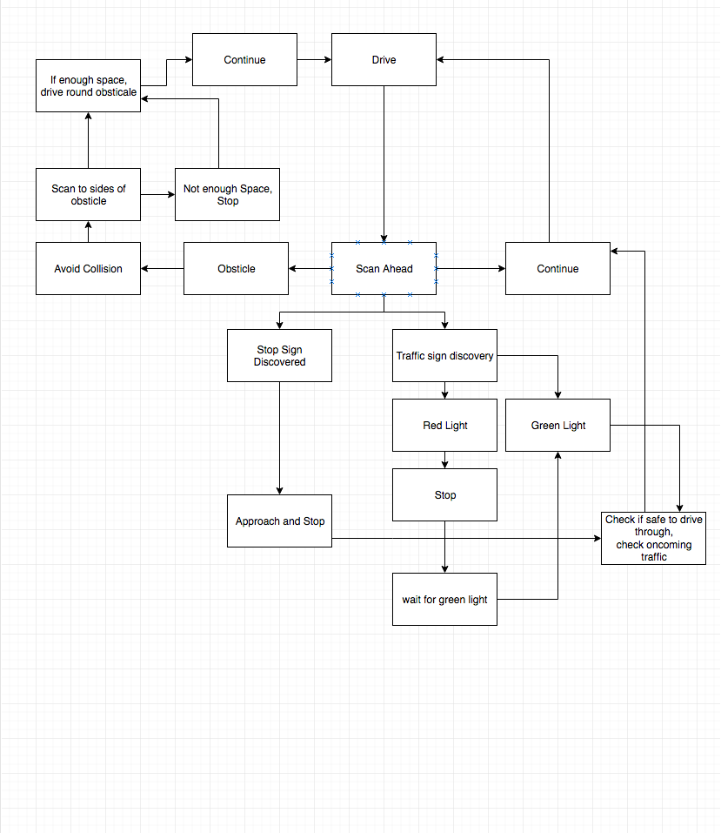

# Gameplay Mechanics

## Controls

The default control scheme for this game will be laid out on a keyboard

W – Gas

S – Break

AD – Steering left, right

Spacebar – Handbrake

[ ] – Indicators

P – Pause the game

Esc – Pause game show menu

## Objectives

Objectives are derived from the scenario parts that will be displayed to the user, they will need to be completed in order to pass the scenario and earn a “mark” on the performance from the scenario. The objectives will vary between the scenarios as each of them is focusing on a specific part of the road maneuvers.

Some of the objectives will include:

* Proceed to the marked area
* Approach the junction/roundabout cautiously
* Stop in the designated area
* Wait for traffic to clear
* Navigate the junction/roundabout carefully
* Exit the junction
* Maintain correct speed

## Actions

Accelerate – allows the player to increase the speed of the car

Break – allows the player to stop the car

Steer – allows the player to steer the car

Show hint – will show a simple hint based on the current scenario objective

Pause Game – allows the game to be paused

Restart Scenario – allows the scenario to be replayed

Show Breakdown Video – plays a breakdown video of the current scenario

## Menus